CURRICULUM VITAE
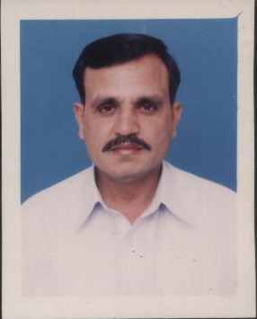
PERSONAL:

NAME: SYED ASHFAQ HUSSAIN SHAH
FATHER’S NAME: SYED AKBAR ALI SHAH
DOMICILE: PUNJAB
N.I.C NUMBER: 61101-1843268-1
CONTACT INFORMATION: VILL& PO MADINA SYEDIAN
GANDRA ROAD NEAR MASJID ARAYIAN
TEHSIL & DISTRICT GUJRAT
E-MAIL: syedashfaqhussain@hotmail.com
MOBILE NO. 0092-300-6224319
0092-334-4664282
DATE OF BIRTH: 01,DECEMBER,1965.
NATIONALITY: PAKISTANI.

TECHNICAL / ACADEMIC QUALIFICATION / EXPERIENCE

SERVICE EXPERIENCE

Retired from Pakistan Navy as Leading Medical Technician (Male Nurse) on completion of 20 years administrative/operational service onboard ship and establishments. During the tenure of service I had performed duties at Pakistan Navy hospitals PNS SHIFA / PNS RAHAT at Karachi and Pakistan Navy hospital PNS HAFEEZ at Islamabad including medical centers of different Ships and Establishments.

At present I am working in medical unit of Lafarge Pakistan Cement Limited (LAFARGE international cement Limited) from August 2006 to 30 Nov 2012.

KNOWLEDGE AND EXPERINCE / COURSES

1. MEDICAL TECHNICIAN COURSE

36 week course in medical technician from Pakistan Navy medical training school
PNS SHIFA (Pakistan Navy hospital) Karachi in 02-03-1986 in followings.

a. Anatomy and Physiology
b. First Aid and Emergency Procedure
c. Elementary Dispensing
d. Hospital Duties
e. Hygiene and Sanitation
f. Medical Surgical and Infectious Diseases Care
g. Medical and Surgical Nursing Procedure

2. GENERAL NURSING TECHNICIAN COURSE

52 weeks in general Nursing Technician from Pakistan Navy medical training school PNS SHIFA (Pakistan Navy hospital) Karachi in 07-12-1991 in followings:

a. Anatomy and Physiology
b. Ward Administration
c. Medical Diseases & Nursing Care
d. Surgical Diseases & Nursing Care
e. Psychiatric Nursing
- Nursing Procedure
- Skin Nursing Care
- Electrocardiography

3. LEADING MEDICAL TECHNICIAN

16 week in Leading Medical Technician from Pakistan Navy medical training school PNS SHIFA (Pakistan Navy hospital) Karachi in 28-03-1994 in followings:

a. Anatomy and Physiology
b. First Aid and Emergency Procedure
c. Hospital Duties
d. Hygiene and Sanitation Procedure
e. Medical Surgical and Infectious Diseases Care
f. Medical and Surgical Nursing Procedure

4. 01 week fire fighting & damage control course at PNS KAKSAZ KARACHI.

5. COMPUTER SKILLS

06 weeks course and practice on modern computer at Pakistan Computer Bureau IT & Telecom Bureau in following:

a. Computer Fundamentals
b. Windows Operating System
c. Ms- Word
d. Ms- Excel
e. Ms-Power point
f. Ms- Access
g. Internet

